**Other Collections**

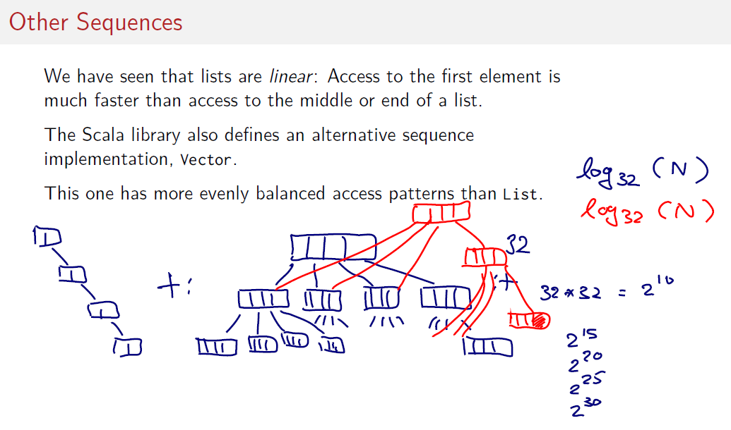

1) Vectors are represented by Trees.

2) The number of access is the deep of the Vector. The deep of the vector is log32(n). This is single index access

3) Vector has better radon access performance profile rather than List. Vector performs better in operations of type map foildRight /left or Filter.

4) List has tends recur to a recursive calls due to the structure. If the access patter has a recursive structure List are better.

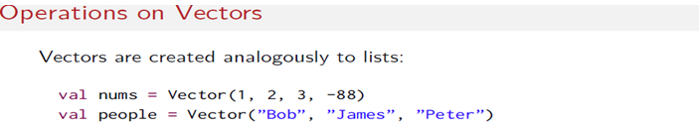

All methods from List are in Vector. The only difference is cons operators.

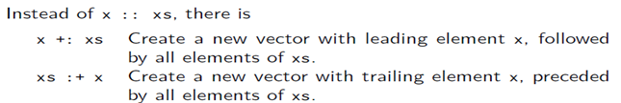

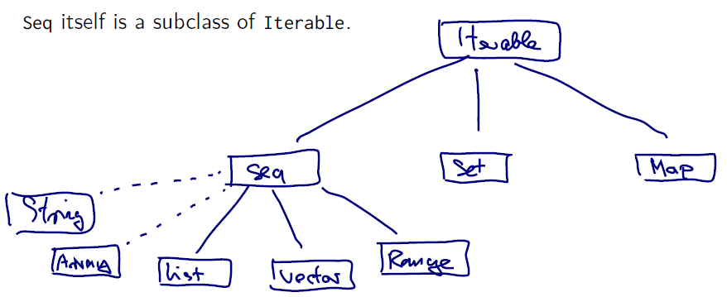

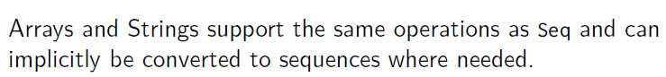

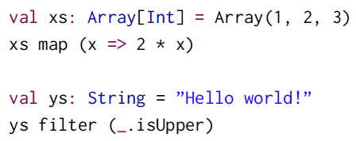

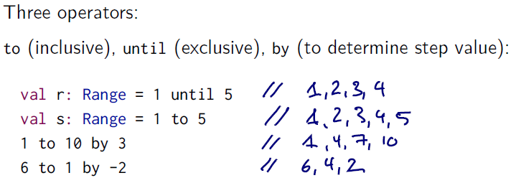



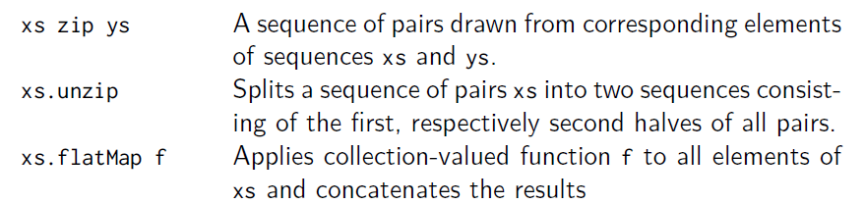

See examples in the slacan project "week6.example.other.collections"

